REVIEW QUESTIONS FOR UNIT 4B EXAM
- Distinguish between veins and arteries.
- Distinguish between the blood components of the followings samples, what do they show about each patient?
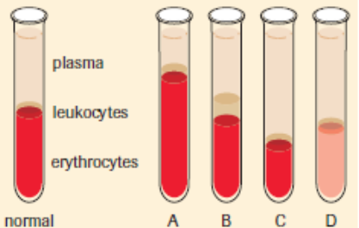
- What are the two circulatory systems? Outline the path of blood through each and state when blood becomes oxygenated and deoxygenated.
- Label the heart:
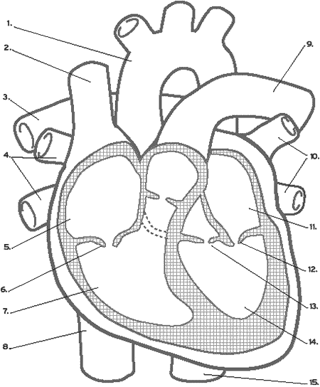
- What is the function of the coronary arteries?
- How do electrical impulses maintain the rhythm of the heart beat?
- What membrane surrounds the heart?
- Jim has a stoke volume of 85 ml/beat and a heart rate of 55 beats/min. What is his cardiac output?
- Distinguish between systolic & diastolic blood pressure.
- What two factors impact Blood Pressure?
- What are the two main functions of blood? The two components?
- What does ECF stand for?
- Explain why a faulty lymphatic system can result in Edema.
- Thermoregulation is the maintenance of ___________________.
- Outline the body’s thermoregulatory response to either an increase or decrease in body temperature
- Erythrocytes have a molecule called __________________ that facilitates the transport of oxygen. What are the two parts of this molecule?
- Biuret solution is added to substances to test whether or not proteins are present. It turns pink (or purple) when added to blood plasma. Does this mean the pink coloration indicates the presence or absence of proteins?
- Draw the process of phagocytosis
- Outline the 5 steps of the blood clotting process (draw a diagram if that helps)
- What are glycoproteins? And how do they contribute to blood groups.
- Explain why agglutination occurs when Blood Type A is transfused into a person with Blood Type B.
- What is the Rhesus factor and how does it impact blood transfusions?
- Briefly describe 3 of the body’s physical (1st line) defenses.
- What are the three process associated with the Second Line of Defence in the immune system?
- Which blood cells are produced in the bone marrow but modified in other locations?
- In what three ways can complement proteins work to render invaders harmless?
- The Third Line of Defence:
T cells identify the intruder and sends back the information to the _____ cells, which then multiple and produce specific ____________. Their specificity comes from the tips of their “y-shaped” end called ____________ regions. This specificity allows for attachment to the invader, thereby tagging it to be destroyed by macrophages. Macrophages then put the invader’s antigen on its cell membrane, so _____________ cells can identify the invader and send signals to B Cells and Killer T Cells.
- What’s the function of Suppressor T Cells and Memory B Cells?
- How do lungs and skin contribute to excretion of waste?
- Outline the process of deamination
- Label the kidney:

- How does bicarbonate buffering system help maintain blood’s pH level?
- Label the diagram of the nephron and outline the substances being FILTERED in the glomerulus, REABSORBED at the tubules and loop of henle, and SECRETED into the tubules.

